Лабораторная работа №4  Реализация SQL-запросов базы данных  Тема: кинотеатр | Ф.И.О. | Григорьев И.М.
 | Группа | ИВТ-263
 | Преподаватель | Соколов Александр
 | Дата сдачи

Цель работы: создать 100 SQL-запросов.

Ход работы:
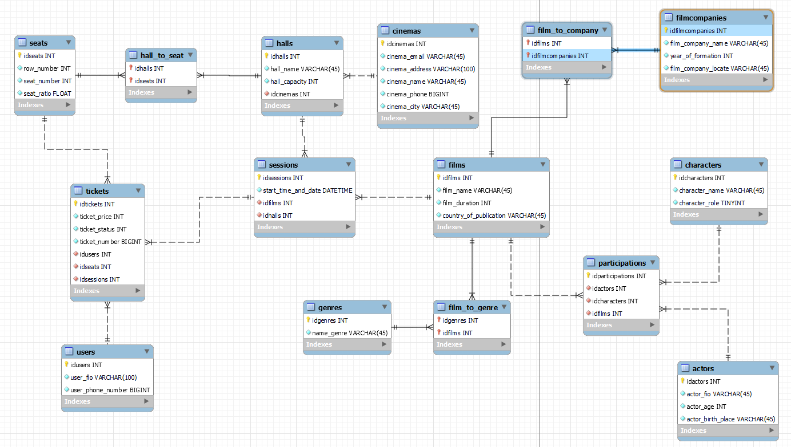

Код запросов:
-- собственные запросы
-- функциональные
select * from cinemas
where cinema_city = "Волгоград";

select * from users
where user_fio = 'Кулагин М. Д.';

select * from films
where film_name = "Волгоград";

select
f.film_name,
s.start_time_and_date,
(h.hall_capacity - count(t.ticket_status = 1)) as "Кол-во свободных мест"
from films as f
join sessions as s on s.idfilms = f.idfilms
join halls as h on h.idhalls = s.idhalls
join tickets as t on t.idsessions = s.idsessions
group by f.film_name;

select
a.actor_fio,
a.actor_age,
a.actor_birth_place
from actors as a
join participations as p on p.idactors = a.idactors
join films as f on f.idfilms = p.idfilms
where f.film_name = 'Анчартед: На картах не значится';

select
c.character_name,
c.character_role
from characters as c
join participations as p on p.idcharacters = c.idcharacters
join films as f on f.idfilms = p.idfilms
where f.film_name = 'Анчартед: На картах не значится';

-- аналитические
select
t.ticket_price,
s.seat_ratio,
(t.ticket_price * s.seat_ratio) as "Стоимость билета"
from seats as s
cross join tickets as t on t.idseats = s.idseats
group by ticket_price;

select
f.film_name,
s.start_time_and_date,
h.hall_capacity,
count(t.ticket_status) as "Кол-во купленных мест",
(h.hall_capacity - count(t.ticket_status)) as "Кол-во свободных мест"
from films as f
join sessions as s on s.idfilms = f.idfilms
join halls as h on h.idhalls = s.idhalls
join tickets as t on t.idsessions = s.idsessions
where (s.start_time_and_date between '2022-08-17 00:00:00' and '2022-08-18 00:00:00') and t.ticket_status = 0
group by f.film_name;

select
f.film_name,
count(t.ticket_status) as "Кол-во купленных мест"
from films as f
join sessions as s on s.idfilms = f.idfilms
join halls as h on h.idhalls = s.idhalls
join tickets as t on t.idsessions = s.idsessions
where (s.start_time_and_date between '2022-11-17 00:00:00' and '2022-12-17 00:00:00') and t.ticket_status = 1
group by f.film_name;

select * from characters;

-- UPDATE (5шт)

update tickets
set ticket_price = 300
where idtickets = 1;
update seats
set seat_ratio = 1.5, seat_number = 14
where idseats = 7;
update halls
set hall_name = 'IMAX', hall_capacity = 120
where idhalls = 3;
update cinemas
set cinema_phone = 798105
where idcinemas = 5;
update genres
set name_genre = 'юмор'
where idgenres = 7;

select * from genres;

-- DELETE (5шт)
/*
ALTER TABLE `admin_bd`.`pics` DROP FOREIGN KEY `fk_pics_h1` удалить связь
ALTER TABLE `admin_bd`.`pics` ADD CONSTRAINT `fk_pics_h1` FOREIGN KEY (`house_id`) REFERENCES `admin_bd`.`houses`(`id`) ON UPDATE CASCADE ON DELETE CASCADE и добавить такую
для удаления (пример)
*/

INSERT INTO `users` (user_fio, user_phone_number) VALUES
('Самороков М. Д.',89555993628),
('Григорьев М. Д.',89555993628);
INSERT INTO `tickets` (ticket_price, ticket_status, ticket_number, idusers, idseats, idsessions) VALUES
(500,1,4561,1,1,1);
INSERT INTO `participations` (idactors, idcharacters, idfilms) VALUES
(11,1,1);
INSERT INTO `halls` (hall_name, hall_capacity, idcinemas) VALUES
('3 зал',10,1);
INSERT INTO `genres` (name_genre) VALUES
('комедия');

delete from users
where idusers > 10;
delete from tickets
where idseats > 0 and ticket_price > 400;
delete from participations
where idparticipations = 11;
delete from halls
where idhalls > 0 and hall_capacity < 50;
delete from genres
where idgenres > 0 and name_genre = 'комедия';

-- SELECT, DISTINCT, WHERE, AND/OR/NOT, IN, BETWEEN, различная работа с датами и числами, преобразование данных, IS NULL, AS для таблиц и столбцов и др. в различных вариациях (15шт)

select distinct cinema_city from cinemas;
select distinct hall_name from halls;
select * from halls
where hall_capacity < 100;
select * from actors
where actor_age > 50 and actor_birth_place = 'США';
select * from seats
where `row_number` in (1, 6, 14);
select * from seats
where seat_ratio > 1.5 and seat_ratio < 2.0;
select film_company_name as fcn from filmcompanies;
select year_of_formation as 'Год основания' from filmcompanies;
select * from tickets
where ticket_number between 150 and 5000;
select * from filmcompanies
where `film_company_locate` in ('США: Лос-Анджелес, Калифорния', 'США: Лос-Гатос Калифорния');
select * from actors
where actor_birth_place != 'США';
select * from films
where idfilms = 2 or idfilms > 6;
select * from films
where film_duration < 110;
select ticket_price as 'цена билета' from tickets;
select ticket_number as 'номер билета' from tickets;

select * from films;

-- LIKE (5шт)
select concat_ws (' / ', user_fio, user_phone_number) from users;
select concat_ws (', основан: ', film_company_name, year_of_formation) from filmcompanies;
select character_name from characters
where character_name like 'Э%';
select character_amplua from characters
where character_amplua like 'молод%';
select name_genre from genres
where name_genre like 'дет%' or name_genre like '%о%';

select * from sessions;

-- SELECT INTO или INSERT SELECT (2шт)
create table test(
idtest int not null auto_increment primary key
);
alter table test
add column price int not null;

select * from halls;

insert into test (idtest)
select (idusers) from users;

insert into test (price)
select (ticket_price) from tickets;

-- JOIN: INNER, OUTER (LEFT, RIGHT, FULL), CROSS, NATURAL (15шт)
select * from halls as a join sessions as b on a.idhalls = b.idhalls;
select c.film_name, d.start_time_and_date from films as c join sessions as d on c.idfilms = d.idfilms;

select
*
from users as u
left join tickets as t on u.idusers = t.idusers;

select
t.ticket_price,
s.seat_number
from seats as s
right join tickets as t on s.idseats = t.idseats;

select
f.film_name,
f.film_duration,
s.start_time_and_date,
p.idparticipations
from films as f
join sessions as s on f.idfilms = s.idfilms
join participations as p on f.idfilms = p.idfilms;

select
*
from halls as h
join cinemas as c on h.idcinemas = c.idcinemas
join sessions as s on h.idhalls = s.idhalls;

select
c.cinema_name,
h.hall_name
from cinemas as c
cross join halls as h;

select * from filmcompanies as fc join film_to_company as ftc on fc.idfilmcompanies = ftc.idfilmcompanies;
select * from genres as g join film_to_genre as ftg on g.idgenres = ftg.idgenres;

select
h.hall_name,
h.hall_capacity,
s.seat_ratio,
s.seat_number,
s.`row_number`
from hall_to_seat as hts
join seats as s on hts.idseats = s.idseats
join halls as h on hts.idhalls = h.idhalls;

select
*
from participations as p
join actors as a on p.idactors = a.idactors
left join films as f on p.idfilms = f.idfilms;

select
a.actor_fio as 'ФИО актера',
c.character_name as 'ФИО персонажа'
from participations as p
join characters as c on p.idcharacters = c.idcharacters
join actors as a on p.idactors = a.idactors;

select
f.film_name,
fc.film_company_name,
fc.year_of_formation
from film_to_company as ftc
join filmcompanies as fc on ftc.idfilmcompanies = fc.idfilmcompanies
join films as f on ftc.idfilms = f.idfilms;

select
u.user_fio,
t.ticket_price,
s.seat_ratio,
t.ticket_number
from tickets as t
join users as u on t.idusers = u.idusers
right join seats as s on t.idseats = s.idseats;

-- GROUP BY (некоторые с HAVING), с LIMIT, ORDER BY (ASC|DESC) вместе с COUNT, MAX, MIN, SUM, AVG в различных вариациях, можно по отдельности (15шт)
select * from users order by user_fio;
select * from actors order by actor_fio desc;
select count(*) from tickets;
select count(distinct cinema_city) from cinemas;
select min(hall_capacity) from halls;
select max(hall_capacity) from halls;
select sum(hall_capacity) from halls;
select avg(hall_capacity) from halls;
select avg (year_of_formation) from filmcompanies;
select ticket_price, avg(ticket_number) from tickets group by ticket_price;
select count(idfilms), country_of_publication
from films
group by country_of_publication;
select count(idfilms), country_of_publication
from films
group by country_of_publication
having count(idfilms) > 3;
select count(idhalls), hall_name
from halls
group by hall_name
having count(idhalls) >= 2
order by hall_name;
select * from filmcompanies order by film_company_name;
select * from tickets order by ticket_price desc;
select count(idgenres) from genres;

select * from films;

-- UNION, EXCEPT, INTERSECT (3шт)
select price as cost
from test
union select ticket_price
from tickets
order by cost;
/*
select f.film_name, f.film_duration, s.start_time_and_date
from films as f
left join sessions as s on f.idfilms = s.idfilms
order by film_name
except
select f.film_name, f.film_duration, s.start_time_and_date
from films as f
right join sessions as s on f.idfilms = s.idfilms;

select f.film_name, f.film_duration, s.start_time_and_date
from films as f
left join sessions as s on f.idfilms = s.idfilms
order by film_name
intersect
select f.film_name, f.film_duration, s.start_time_and_date
from films as f
right join sessions as s on f.idfilms = s.idfilms;
*/

-- SELECT с GROUP BY, ALL, ANY, EXISTS (3шт)
select cinema_name
from cinemas
where idcinemas = any
(select idcinemas
from halls
where hall_capacity > 150);

select cinema_name
from cinemas
where idcinemas = all
(select idcinemas
from halls
where hall_capacity=100);

select cinema_name
from cinemas
where exists
(select distinct hall_name
from halls
where halls.idcinemas = cinemas.idcinemas and hall_capacity between 70 and 95);

-- GROUP_CONCAT (2шт)
select group_concat(film_name separator ' ||| ') as film_names from films;
select group_concat(cinema_email separator ' / ') as cinema_emails from cinemas;

-- WITH (2шт)

with cte_hall_capacity as
(
select idhalls, hall_name, hall_capacity from halls where hall_capacity < 120
)
select * from cte_hall_capacity where idhalls in(1, 2, 3);

with cte_film_name as
(
select idfilms, film_name, film_duration from films where lower(film_name) like ("анч%")
)
select * from cte_film_name where idfilms >0;

-- Сложные запросы, входящие в большинство групп выше, т.е. SELECT ... JOIN ... JOIN ... WHERE ... GROUP BY ... ORDER BY ... LIMIT ...; (5шт), можно написать больше вместо простых.

select
a.actor_fio,
g.name_genre
from actors as a
join participations as p on p.idactors = a.idactors
join films as f on f.idfilms = p.idfilms
join film_to_genre as ftg on ftg.idfilms = f.idfilms
join genres as g on g.idgenres = ftg.idgenres
where g.name_genre like 'дет%' or g.name_genre like '%о%'
group by a.actor_fio
order by g.name_genre desc;

select
a.actor_fio,
a.actor_age,
c.character_name
from actors as a
join participations as p on a.idactors = p.idactors
join characters as c on c.idcharacters = p.idcharacters
where a.actor_age > 45
group by a.actor_fio
order by a.actor_age desc limit 3;

select
f.film_name,
fc.year_of_formation
from films as f
join film_to_company as ftc on f.idfilms = ftc.idfilms
join filmcompanies as fc on fc.idfilmcompanies = ftc.idfilmcompanies
where fc.year_of_formation > 1980
group by f.film_name
order by fc.year_of_formation desc limit 3;

select
c.character_name,
f.film_name
from characters as c
join participations as p on p.idcharacters = c.idcharacters
join films as f on f.idfilms = p.idfilms
where c.character_role = 1
group by c.character_name
order by c.character_name;

select
h.hall_name,
avg(s.seat_ratio*t.ticket_price) as "Средняя стоимость по залу"
from seats as s
join hall_to_seat as hts on hts.idseats = s.idseats
join halls as h on h.idhalls = hts.idhalls
join tickets as t on t.idseats = s.idseats
group by h.hall_name
order by avg(s.seat_ratio*t.ticket_price) desc;

select * from halls;
select * from seats;

-- //////////////////////////////МОДА////////////////////////////////////////////
-- 1
select
c.cinema_name,
s.start_time_and_date
from sessions as s
join films as f on s.idfilms = f.idfilms
join halls as h on s.idhalls = h.idhalls
join cinemas as c on h.idcinemas = c.idcinemas
where (s.start_time_and_date between '2022-08-17 00:00:00' and '2022-12-17 00:00:00') and (c.cinema_name = 'Гиппопо');

-- 2
alter table tickets
modify ticket_status int;

select
*
from films as f
join sessions as s on s.idfilms = f.idfilms
join halls as h on h.idhalls = s.idhalls
join tickets as t on t.idsessions = s.idsessions;

-- доделать подсчет
select
f.film_name,
s.start_time_and_date,
h.hall_capacity,
count(t.ticket_status) as "Кол-во купленных мест",
(h.hall_capacity - count(t.ticket_status)) as "Кол-во свободных мест"
from films as f
join sessions as s on s.idfilms = f.idfilms
join halls as h on h.idhalls = s.idhalls
join tickets as t on t.idsessions = s.idsessions
-- where t.ticket_status > 0
group by f.film_name;

select * from films;

INSERT INTO `tickets` (ticket_price, ticket_status, ticket_number, idusers, idseats, idsessions) VALUES
(300,1,4561,1,1,5),
(300,1,4561,1,1,5),
(300,1,4561,1,1,5),
(300,1,4561,1,1,5);

select * from tickets;

INSERT INTO `tickets` (ticket_price, ticket_status, ticket_number, idusers, idseats, idsessions) VALUES
(300,1,4561,1,1,2),
(300,1,4561,1,1,2),
(275,1,15613,2,2,2),
(275,1,15613,2,2,2),
(275,1,15613,2,2,2),
(400,1,156,3,3,3),
(400,1,156,3,3,3),
(400,1,156,3,3,4),
(400,1,156,3,3,4),
(400,1,156,3,3,4),
(400,1,156,3,3,4),
(400,1,156,3,3,4),
(55,1,896,4,4,4),
(365,1,894,5,5,6),
(100,0,132,6,6,6),
(100,0,132,6,6,7),
(100,0,132,6,6,7),
(100,0,132,6,6,7),
(100,0,132,6,6,6),
(100,0,132,6,6,6),
(100,0,132,6,6,6),
(100,0,132,6,6,6),
(90,0,8798,7,7,6),
(655,0,215,8,8,8),
(310,0,8798,9,9,9),
(310,0,8798,9,9,9),
(310,0,8798,9,9,9),
(160,0,329,10,10,10),
(160,0,329,10,10,1),
(160,0,329,10,10,1);

-- 3
INSERT INTO `actors` (actor_fio, actor_age, actor_birth_place) VALUES
("Марк Уолберг", 50, 'США'),
("Марк Руффало", 54, 'США'),
("Патриша Кларксон", 62, 'США'),
("Мишель Уильямс", 41, 'США');
INSERT INTO `characters` (character_name, character_role) VALUES
('Виктор Салливан', 1),
('Чак Оул', 1),
('Рэйчел Соландо', 1),
('Долорес', 1);
INSERT INTO `participations` (idactors, idcharacters, idfilms) VALUES
(11,11,4);

select
a.actor_fio,
count(p.idactors) as "Кол-во участий в фильмах"
from actors as a
join participations as p on p.idactors = a.idactors
group by a.actor_fio
order by count(p.idactors) desc limit 3;

